WBFL Extensible Application Framework

Introduction
The WBFL Extensible Application Framework (EAF) will provide WSDOT with a consistent, re-usable, and extensible application framework for delivering its structural engineering applications. The Extensible Application Framework is a refinement on the extensible architectures that have been highly successful in the Barlist, PGSuper, and PGSplice applications.

The primary motivations for developing the EAF are to ease long term software maintenance burdens, to provide a more flexible framework for building and maintaining applications, and to enable application extensions to be developed and seamlessly integrated into existing applications.

WSDOT does not have the resources to maintain all of its in-house structural engineering applications in their present form. The long term maintenance of the PGSplice and PGSuper programs provide a specific example. These programs share similar application architectures and perform similar functions; however PGSplice has not been maintained at the same level as PGSuper. If the common functions of these applications are shared in a common application framework, many of the features could be maintained as one application.

The open source software concept has been extremely successful for WSDOT. The partnership with TxDOT has brought many returns on our investment in the PGSuper application. TxDOT has made considerable financial and time investments in the development, enhancement and validation of PGSuper. As we go forward, in partnership with TxDOT, it is clear that the software architecture must be enhanced to provide for specialized features and components that can be optionally included in a software distribution. WSDOT requires the development of features that TxDOT does not, and visa-versa. A prime example of existing features that should be made optional is agency specific reporting. TxDOT and WSDOT both have custom reports that present key data in agency specific formats. WSDOT users don’t need the TxDOT reports; TxDOT users don’t need the WSDOT reports. Furthermore, others users don’t need either of these reports but likely have a need to add new their own custom reports. Architecture changes are needed to eliminate this undesirable feature overlap.

While the undesirable feature overlap is minimal at this time, it will grow to the point that the software will become confusing to the user. Engineers will become uncertain as to which features are to be used and will find the unwanted agency-specific features bothersome. We anticipating that other DOTs will get involved with PGSuper development, the number of DOT-specific features will grow adding to the confusion. It would be best to install a WSDOT customized version on WSDOT computers and enable TxDOT and others to do the same.

To accommodate all the specializations, while maintaining the benefits of collaborative development, an application architecture that accommodates optional features that can be “plugged in” is required. The WBFL Extensible Application Framework will provide the desired application architecture.

The WBFL Extensible Application Framework is an abstract software entity. The framework provides the structure and basic functionally needed by an extensible application; however it is not an application itself. BridgeLink is a specific application that utilizes the WBFL Extensible Application Framework (the details of the BridgeLink application are presented elsewhere). It is sometimes beneficial to explain the abstract nature of the EAF through a concrete example. From time to time, abstract concepts will be described in terms of the BridgeLink application. Note that BridgeLink is only one of many applications that can be built from the WBFL Extensible Application Framework.

EAF Architecture Overview
This section will provide a high level description of the Extensible Application Framework architecture. The description will begin with a narrative describing the experience a user will have when first running the BridgeLink application.

Before the application is installed a user will have learned that BridgeLink provides a family of integrated bridge engineering applications. The applications include a coordinate geometry and roadway modeling application, a generic bridge geometry modeling application, and a precast-prestressed girder design and analysis application. Upon starting the software the user will be prompted to create a new project. The project types are presented in a dialog similar to the one shown here.

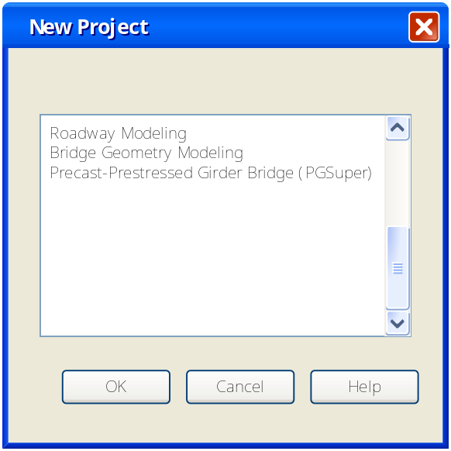

Once the project type is selected, BridgeLink will create the project and the user will use the various features of the application. If, for instance, a Roadway Modeling project was created, the user would select commands from the menus to describe the alignment, cross-section, and profile of a roadway. The roadway would be graphically presented in different views and could be manipulated with mouse-clicks and other user generated events. Information about the roadway, such as elevations, would be tabulated, reported, printed, and exported to other applications.

Each of the project types are BridgeLink Application Plug-ins, or more specifically, WBFL Extensible Application Framework Plug-ins that have been customized for the BridgeLink application. An application plug-in is a software component that conforms to a pre-defined protocol in order to integrate itself into and communicate with the BridgeLink application. An application plug-in provides the specific functionality of the component (such as coordinate geometry). The software installer registers the components as a BridgeLink Application Plug-in. When BridgeLink starts, it queries for registered application plug-ins, loads them into memory, and presents them to the user. This dynamic initialization process allows for new BridgeLink Application Plug-ins to be developed by anyone and added into the system at anytime. Figure 1 shows a high level view of the application architecture.
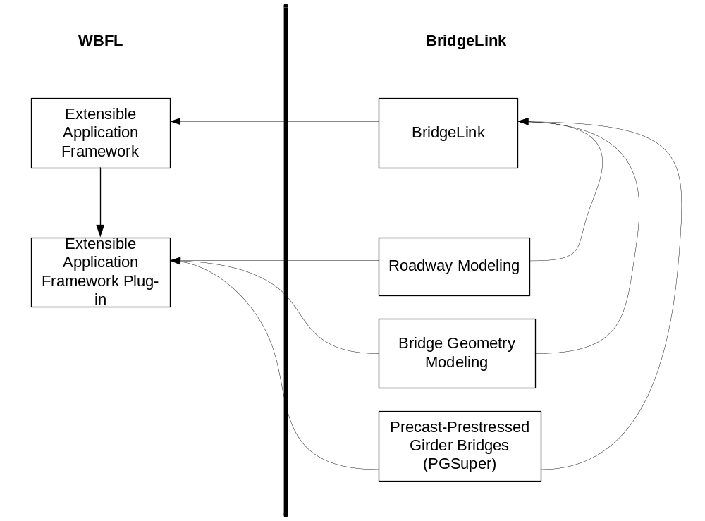
Figure 1 WBFL Extensible Application Framework

EAF Application Plug-in Overview
Applications using the Extensible Application Framework architecture are extended by creating and registering EAF Application Plug-ins. Each application plug-in essentially provides a new project type for the application. Application plug-ins provides its own windows, menus, dialogs, reports, graphs, data persistence, and unique functionality. Every application plug-in has its own internal architecture. The basic MFC Doc/View architecture may suffice for a simple plug-in. A complex plug-in such as PGSuper will require a much more robust architecture.

Agent/Broker Architecture Overview
The WBFL currently provides the Agent/Broker architecture. The PGSuper and PGSplice applications successfully use this architecture. It is a very extensible, flexible, and robust architecture.

The Agent/Broker architecture decouples access to data and methods (“services”) from the implementation and allows for new “services” to be added to an application without modifying its implementation. Agents do all of the “work” of an application. That is, they provide the functionality of a program. The Broker receives requests for information and forwards them on to the agent that can fulfill the request. When a graph, report, dialog, view window or agent needs information, it simply goes to the broker and requests the interface from which the information can be obtained. The requesting entity has no idea from where in the program that interface is implemented; it just knows to get the interface from the broker and to request the information.

When an agent is on the receiving end of a request (a method on an interface that it implements is called), the agent does whatever work is necessary to fulfill that request. This might include requesting other interfaces from the broker, computing data, and/or looking up previously cached data. Figure 2 shows the main thread of execution in an Agent/Broker application.
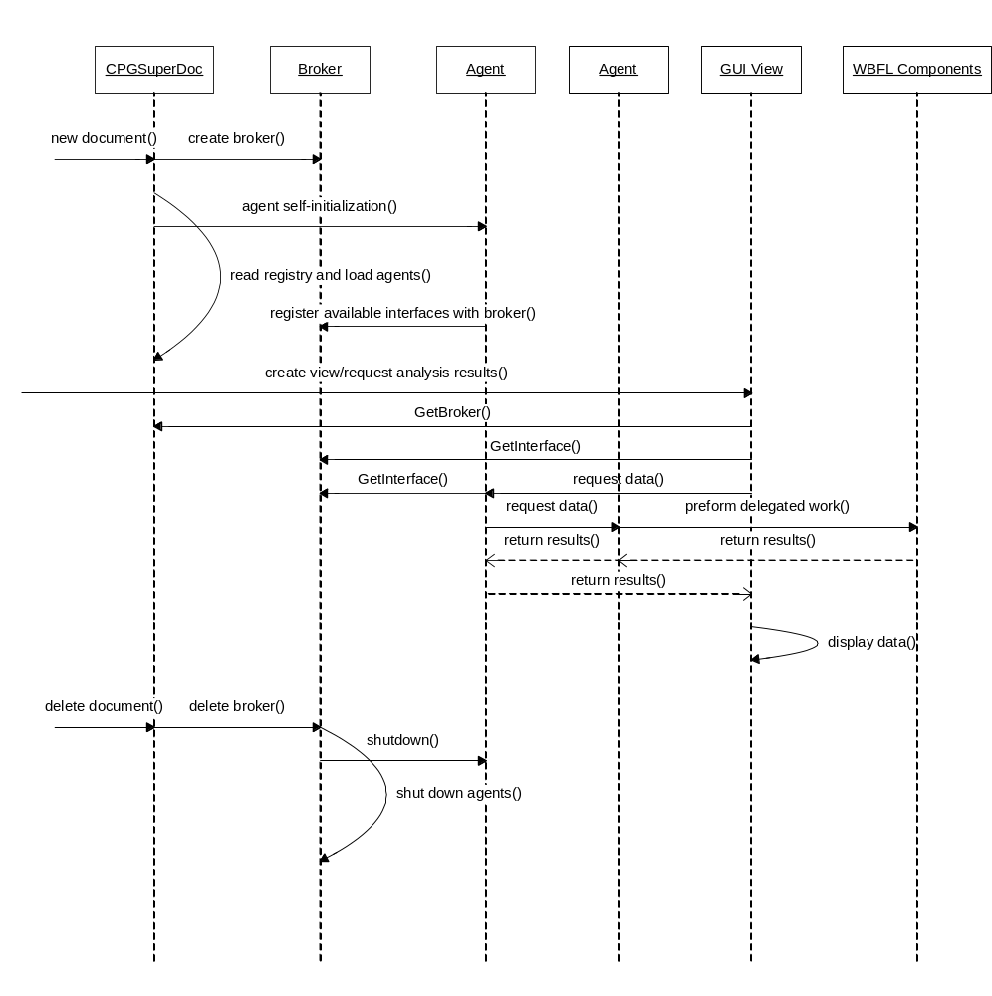
Figure 2 Agent/Broker Main Sequence

Agents are registered with an application’s COM Component Category and are dynamically integrated into an application or application plug-in at runtime.

Application Extensibility
EAF-based applications (such as BridgeLink) using application plug-ins based on the Agent/Broker architecture have two levels of extensibility. As previously discussed, new EAF application plug-ins can be created and dynamically integrated into an application as new project types. Agents can be created and dynamically integrated into an EAF Agent/Broker application plug-in extending its functionality as well. Figure 3 shows the Agent/Broker architecture and both levels of extensibility.
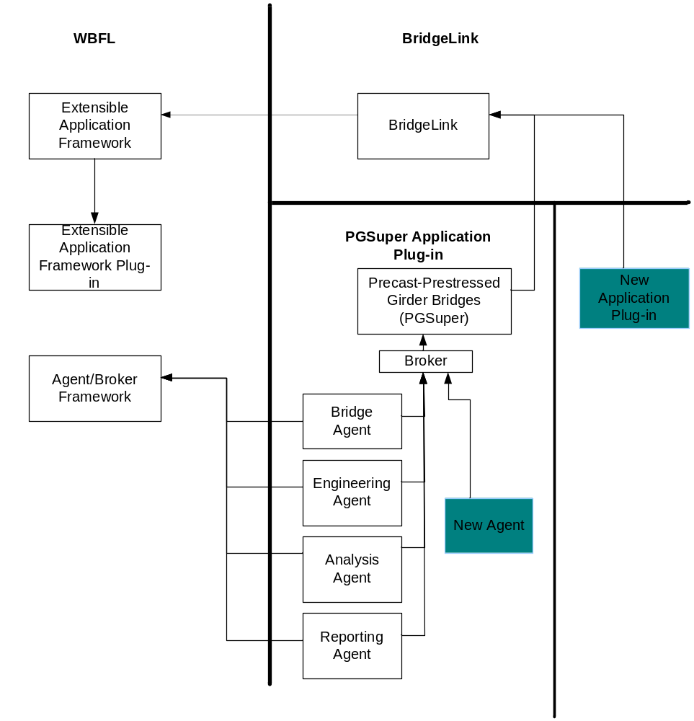
Figure 3 Extensibility of EAF and Agent/Broker Architectures

With careful design and implementation, agents and application plug-ins can share common code thereby reducing the development and maintenance of the overall software system.

EAF Architecture Details
The WBFL Extensible Application Framework extents the MFC Doc/View architecture by providing services for runtime identification and initialization of EAF Application Plug-ins. The EAF manages the lifecycle of EAF Application Plug-ins.

interface IEAFAppPlugin
Abstract interface that is to be implemented by all EAF application plug-ins. This interface defines the protocol for communication with the plug-in.
Methods
virtual void Init() = 0;
A general purpose initialization function that is called by the application framework after all plug-ins are loaded.

virtual void Terminate() = 0;
Called by the framework just prior to the plug-in being unloaded from the application.

virtual CDocTemplate* CreateDocTemplate() = 0;
Returns the document template for the plug-in. The view associated with this template will be the first plug-in created view shown to the user. Create a new document template on the heap. The application framework will be responsible for deleting the template.

virtual CCmdTarget* GetCommandTarget() = 0;
Returns a command target for the plug-in. This command target will be integrated into the MFC command routing procedure.

class CPluginManager
Creates, managers, and destroys the EAF Application Plug-ins.

virtual BOOL LoadPlugins(const CATID& catid);
Loads all of the plug-ins for the given component category ID. Returns true if all the plug-ins are successfully loaded.

virtual void UnloadPlugins();
Causes all of the plug-ins to be unloaded.

virtual void RegisterDocTemplates(CWinApp* pApp);
Called by the application framework during application initialization. Causes the application plug-ins to create and register their document templates.

virtual BOOL OnCmdMsg(UINT nID, int nCode, void* pExtra, AFX_CMDHANDLERINFO* pHandlerInfo);
Called by the application framework during message routing. Forwards the current command to an application plug-ins command target.

class CEAFApp
Abstract base class for all Extensible Application Framework applications.

virtual LPCTSTR GetRegistryKey() = 0;
Returns the application settings registry key (usually a company name). The return value is passed to CWinApp::SetRegistryKey().

virtual OLECHAR* GetPluginCategoryName() = 0;
Returns the name of the application’s plug-in component category.

virtual CATID GetPluginCategoryID() = 0;
Returns the category id for the application’s plug-in component category.

virtual void RegisterDocTemplates();
Called by the framework causing the document templates of the plug-ins to be registered.

class CEAFDocTemplate
Base class for document templates

CEAFDocTemplate(UINT nIDResource,CRuntimeClass* pDocClass,CRuntimeClass* pFrameClass,CRuntimeClass* pViewClass,HMENU hSharedMenu = NULL, int maxViewCount = -1);

Constructor
hSharedMenu = handle to a shared menu. If the menu is shared, you are responsible for allocating it and destroying it.
maxViewCount = limit on number of views of this type can be created. Use a value of -1 for unlimited.

class CEAFMainFrame
The main application window.

CView* CreateOrActivateFrame(CEAFDocTemplate* pTemplate);
Creates a new frame with the CView class defined in the template. If the number of instances of the view is at its limit, the last view of the type will be made the active view.

Returns the new or activated view.

void CreateCanceled();
Call this method during the view creation process to cancel the creation of the view.

BOOL DisableFailCreateMessage() const;
Returns true if the failed to create view message is disabled

void DisableFailCreateMessage(BOOL bDisable = TRUE);
Enables or disables the message that would be shown to the user when the view creation fails.

Thinks to work on/test
- Design method for plug-in agents to integrate with menu, create new menus, and toolbars
- Plug-in agent views

